

**DEPARTMENT OF MECHATRONICS AND ROBOTICS**

**MEC104 2020-2021**

*Fire Alarm*

**Group Report Assignment**

Group number: A34

|  |  |
| --- | --- |
| Student Name | Student ID |
| Zhongpei.Wang | 1928748 |
| Zhihan.Zhang | 1929070 |
| Qihang.Yao | 1930733 |

**Contents**

**Abstract……………………………………………………….1**

**1. Introduction………………………………………………..1**

**2. Experimental procedure…………………………………..3**

1) Theory………………………………………………………………...3

2) Circuit Design………………………………………………………...5

3) Code structure………………………………………………………...6

4) Problems during debugging…………………………………………..8

5) Discussion……………………………………………………………..9

6) Results………………………………………………………………..10

**3. Conclusion………………………………………………....10**

**4. Author list and contributions…………………………….10**

**5**. **References…………………………………………………10**

**6. Appendix…………………………………………………..12**

***Abstract***

*Arduino, as the model of multifunctional integrated circuit board in the new electrical era, provides us with a variety of project development paths. In this project, we made a fire alarm that can be used in a variety of places. It can monitor the temperature and the concentration of harmful gases and alarm in the form of sound and light under abnormal conditions. The circuit connection and code design fully reflect the high flexibility and functional plasticity of the Arduino board. After debugging, the objectives of this project have been achieved and had a certain robustness. Through this project, our understanding of Arduino has entered a new dimension. This will be of great benefit to our future study.*

**1. Introduction**

In modern life, the guarantee of security is more and more important in the circumstances around citizens especially in skyscrapers. The biggest threaten and danger of skyscrapers is the fire hazard. Sometimes a small flame may cause bad catastrophe. In this case, a practical temperature and harmful smoke alarm system is needed. This system we designed is consists of a temperature sensor, a smoke sensor, an LED and a screen. When the sensors discover critical environment which has high temperature or high concentration of harmful gases or both the LED will turn its color from green to red and the buzzer will tweet for the alarm. The temperature and the concentration of gas will occur on the screen. This system can then notify the dangerous situation to let people around to begin the urgent evacuation. This project was completed by Arduino board and through the procedure of exploration we have learned a lot about the Arduino and the circuit design.

**2. Experimental procedure**

**1) Theory**

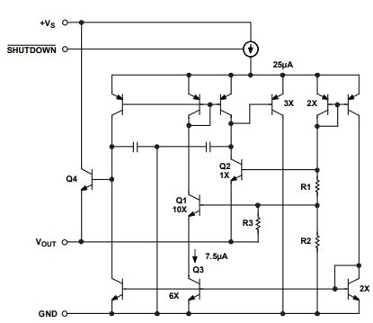The needed theory of this project is very clear and brief. The most important part is the principles of the temperature sensor. The thermistor is the most widely used electronic device in temperature sensors. It is a kind of resistor that is sensitive to the change of temperature and will change its resistance when the temperature goes high or low. In this project, we will use the TMP 36 sensor to test the temperature. The temperature sensor simplified equivalent circuit is shown below:

Fig. 1. The simplified equivalent circuit for temperature sensor

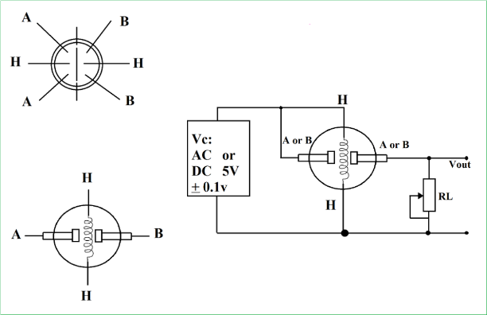For the gas sensor the principles may be a bit complex. The air and the measured gas are diffused to the induction electrode through the diffusion film. The control circuit maintains a voltage between the induction electrode and the opposite electrode sufficient to initiate electrochemical reactions. Electrochemical reactions in the presence of the gas under test will create an electric current between the poles. The sensor's rapid response allows it to detect the surrounding air in real time and continuously. Those functions are connected and integrated by Arduino board. You can follow a basic structure of Gas sensor shown in Fig.2. The circuit design part will illustrate this later in detail.

Fig. 2. The structure of Gas sensor

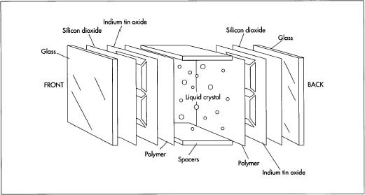What is more important is the principle of the LCD screen. LCD working principle is: under the action of electric field, using the liquid crystal molecules are arranged to change the direction and the light transmittance (modulation) to complete the electric light transformation. The simple structure of LCD display is shown below:

Fig.3. The structure of LCD display

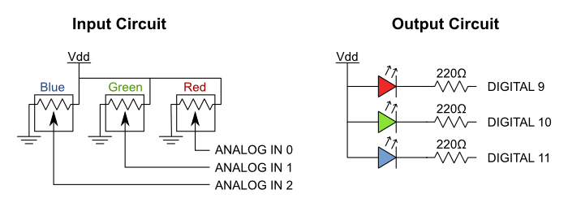Through the reusing of R, G, B three different incentives of the primary signal and red, green and blue three colors filter membrane to complete the color reproduction of time domain and space domain. The structure of RGB light is shown below.

Fig.4. RGB Light

**2) Circuit Design**

In this project we mainly use five devices. Gas transducer, temperature sensor, buzzer, LCD display and a RGB light. The Potentiometer is used to adjust the LCD display’s brightness. Gas transducer and temperature sensor are used to detecting the gas density and the temperature value. The buzzer is used to send alarm to people so that people will know the danger and quickly move away. The LCD display is used to show the current gas density and temperature value. The RGB light is a temperature alarm light. When the temperature is smaller than 50℃, the RGB will show green light. When the temperature is larger than 50℃ but smaller than 100℃, the RGB light will show yellow light. When the temperature is larger than 100℃, the RGB light will show red light.

The circuit diagram is shown below: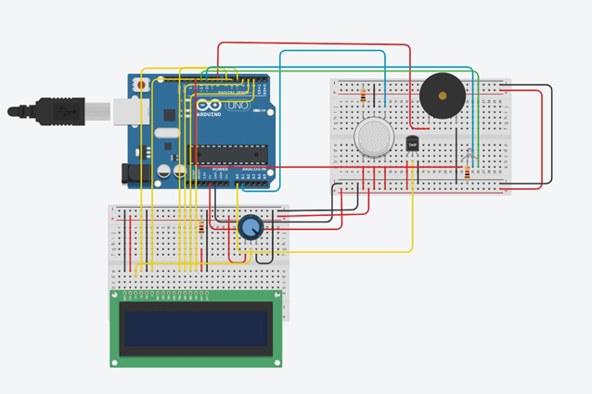

Fig. 4. Fire Alarm

**3) Code structure**

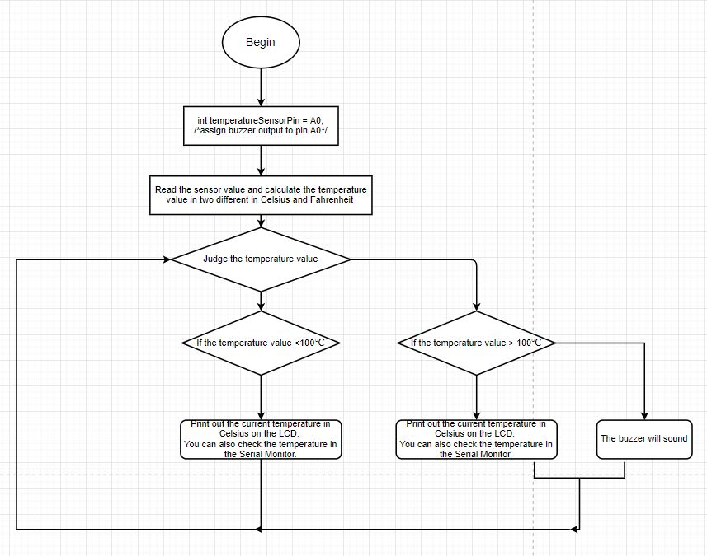For the principle of temperature sensor

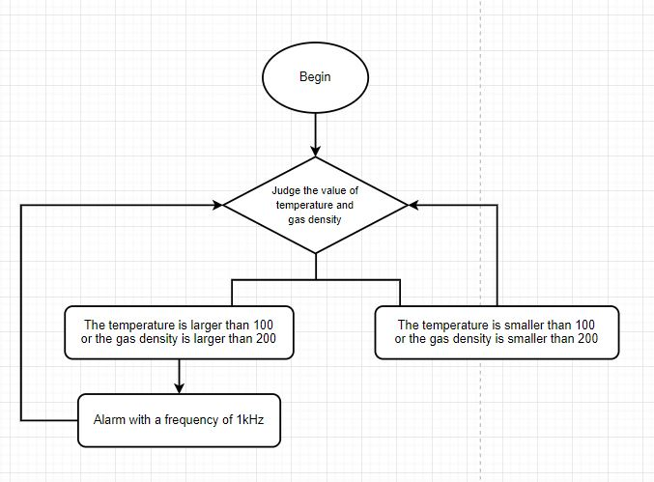For the Gas sensor:

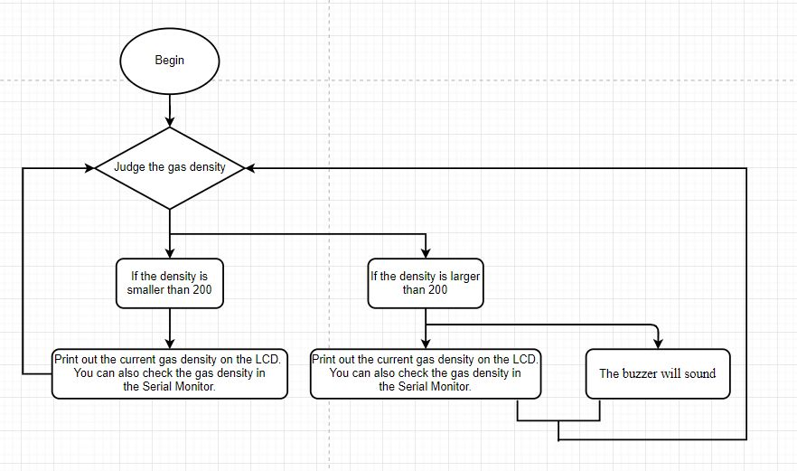For buzzer:

For the RGB light:

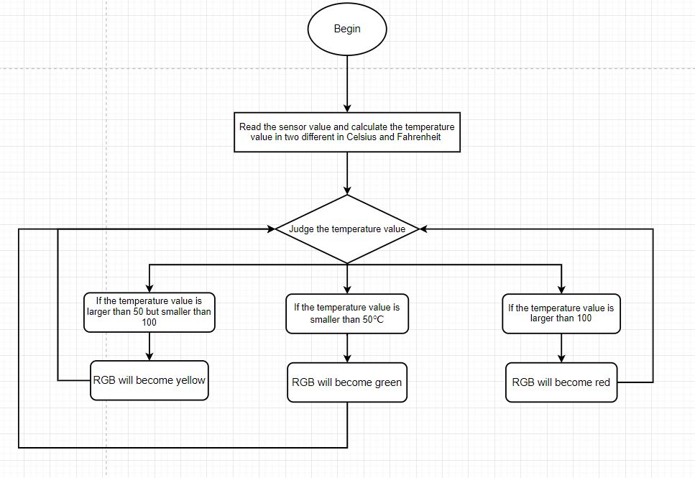

**4) Problems during debugging**

This design can be divided into the following parts. This time, the whole repair process will be described by describing the bugs generated by each part.

The first part is the input part, that is, the gas sensor and the temperature sensor are connected to the corresponding position according to the requirements, and the input variables are read in the code. The whole process is relatively simple, basically the written part, and no obvious bugs appear.

The output end is mainly composed of three parts: a buzzer, an RGB light-emitting diode and an LCD display. The first is the buzzer, and the buzzer with different sounds can be obtained by setting the frequency. No obvious bug was found after the line connection as required.

Followed by RGB lamp respectively by the three interfaces to connect after set R, G and B values for different colors of light, this experiment because only in different state is set in three different colors of light so is relatively simple, only after the first complete set lit up the order of the input error, return to normal after the reversal value.

Finally for the LCD display, because the screen contains a large number of interfaces to connect, so use is difficult, eight known its interfaces exist two kinds of input mode, a serial interface to connect only four inputs and will eight interface parallel input mode of all links, because this experiment interface is limited, so using the serial input way. However, after the first connection, the screen burning fault occurred. After inspection, it was found that the connecting end of LED also needed to connect the resistance, and the problem was solved after the connection. The use of LCD screen is more complex and there are many problems. Finally, we found that there is a library to control the LCD screen, so the problem is solved.

**5) Discussion**

This project can be considered to have only completed the basic rudiment, there is still a large room for improvement. Since RGB diodes can be changed to any color by changing the value, it is possible to loop the color into a gradual state.

According to the similar principle, can also be adjusted to the buzzer. By setting different frequencies, you can get different sounds. You can even connect two buzzers to achieve reverberation effect by setting different frequencies, so as to feedback different conditions.

Due to the limitation of LCD display screen, only 32 letters or numbers can be displayed at the same time, but due to the limitation of interface and unable to connect several LCD display screen, you can consider the button control display data. Although there is no redundant interface, the code can count and convert numbers into time for display, so it can be improved to have electronic clock and other functions.

At the same time, consider logic gates to reduce the number of interfaces used in order to gain more operational space. There are still many improvements to be made based on this platform, and this article describes only those that the author can think of.

**6) Results**

After a long time of commissioning, we finally make the system working properly. When you start the simulation, you will see the current gas density and temperature value on the LCD. If you adjust the gas density or the temperature value, you will see the changes on the LCD display. Moreover, the RGB light and buzzer will also give feedback to you according to your changes. In addition, you can also check the monitor to get more detailed value of the current situation such as the degree Fahrenheit.

**3. Conclusion**

This project has come to a successful conclusion. The fire alarm did its job perfectly. Through this project, we have a deep understanding of the working principle and activation method of integrated multi-sensor and LCD display, and have a deeper impression on how to use them in our daily life. In fact, a real fire alarm is much more complicated than this project and we're just at the beginning of the project. The boundless power of Arduino will lead us to a brighter future of circuit design.

**4. Author list and contributions**

|  |  |  |  |  |
| --- | --- | --- | --- | --- |
| **NO.** | **Name** | **Contribution description** | **Percentage** | **Signature** |
| 1. | Zhongpei.Wang | Code design, report | 33.3% | **王仲佩** |
| 2. | Zhihan.Zhang | Circuit design, report | 33.3% | **张之涵** |
| 3. | Qihang.Yao | Debug, report | 33.3% | **要启航** |

**5**. **References**

[1] S. Monk, *30 Arduino Projects for the Evil Genius*, science press, 2011

[2] C.L. Zhou, Get Started with Arduino, Beihang University press, 2015.

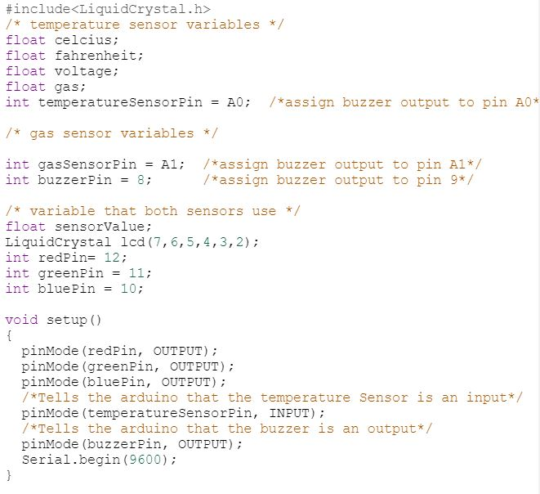**6. Appendix**

